Daniel Pastorelli
Member for Landsdale · Social Media Audit · 4 Mar – 3 Jun 2026

903.8K  FB views | 84%  reach from non-followers | 1.78K  IG followers | -44.9%  IG follow growth | 7.9  posts/week FB

General  Lean hyperlocal and name the suburb. The reach is already here. The gap is converting it into a known, retained local following.  ▸ Big reach, borrowed audience. FB pulled 903.8K views but 84% came from non-followers. Content travels; it is not yet building a base.  ▸ Followers are leaking. IG follow growth down 44.9% over the window with 121 unfollows. FB shows the same churn pattern.  ▸ Carousels win reach, reels win follows but they are so close together. On IG, carousels average the most views (900) but reels bring the most new follows (0.50/post vs 0.14).  ▸ FB video barely registers. Only 16 of 103 FB posts are video, and full-minute views are negligible. Photos carry the page.  ▸ Posting is daytime-heavy. Posts cluster 3–5pm AWST. Only 9 of 86 IG posts land in the 7–9pm evening scroll window. | Strengths  ✓ Strong raw reach — nearly 1M FB views in 90 days  ✓ Healthy cadence, ~8 posts/week, no gaps  ✓ 94% Australian audience — genuinely local  ✓ Consistent daytime posting rhythm  ✓ Reels already pulling follows on IG

On reels
Reels are your follower-acquisition tool, not your reach tool. They bring 3.5x the follows per post of a carousel. So continue to use carousels to reach people but also think about ways your reels can convert them into followers. Keep them short — most run under 30 seconds already, which is right.

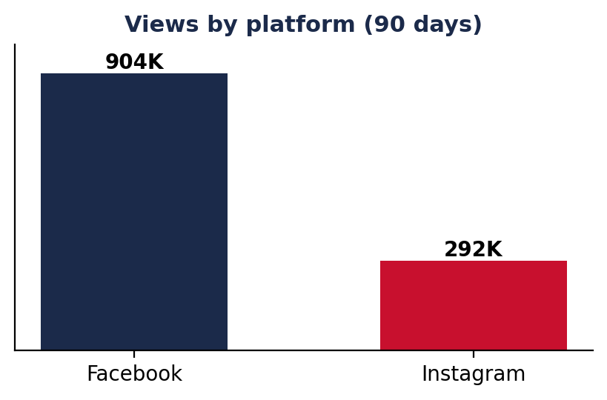 | 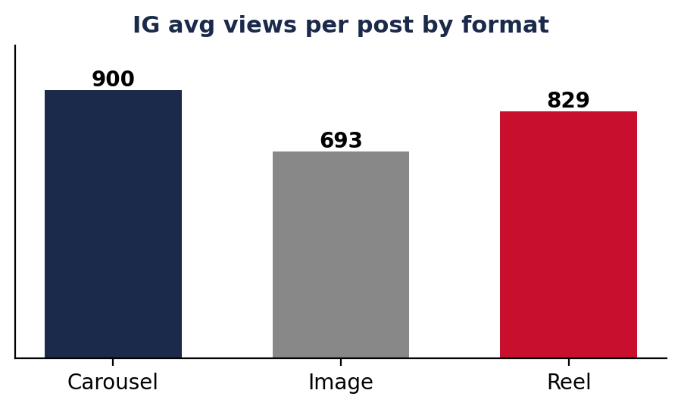
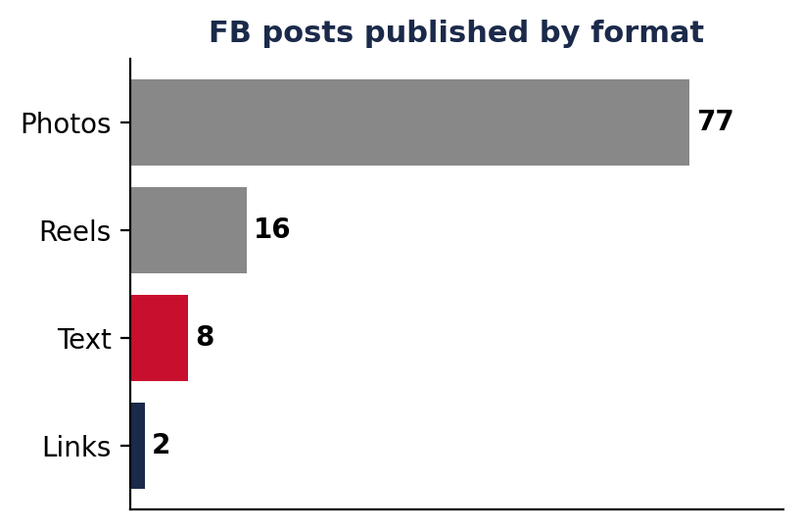 | 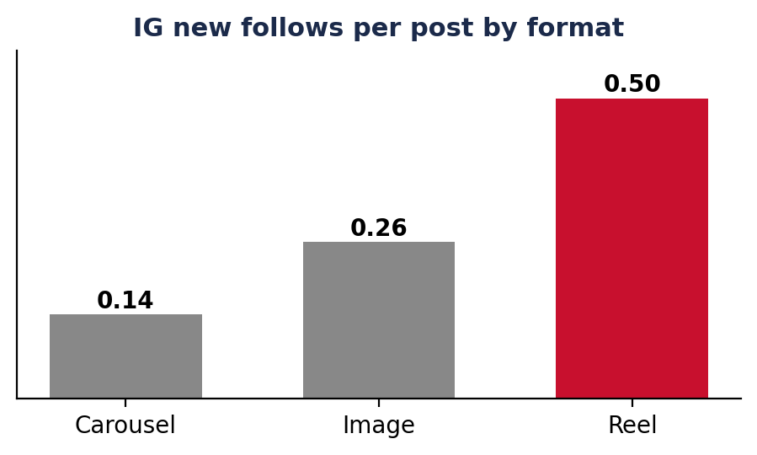

Priority actions
1. Name the suburb. Every post should make clear which part of Landsdale, Darch, Madeley or Marangaroo it is about. Hyperlocal is how a first-termer gets known.
2. Your two best content types are reels and carousels but reels get a lot more follows. Aim for at least 1-2 reels a week aimed squarely at follower growth.
3. Test the evening window. Move 2–3 posts a week into 7–9pm AWST and compare reach against the 3–5pm slot.
4. Stop the follower leak. The unfollow rate is the real problem. Consistent local value.

